**PAC Assignment**

**Implementing an application to fetch details using APIs. Get Statistics for all countries about Covid-19.**

**Final Outcome:**

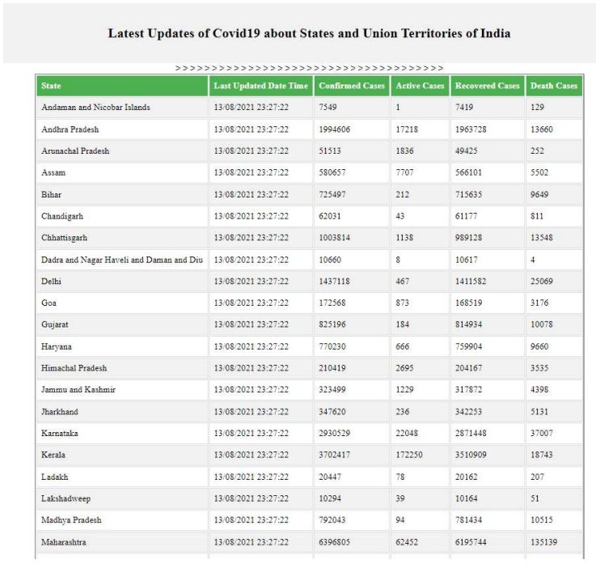

**Code Snippet:**

<!DOCTYPE html>

<html>

<head>

<meta name="viewport" content=

"width=device-width, initial-scale=1.0">

<title>Covid19 Report</title>

<style type="text/css">

.header {

background-image: url('cool-background.png');

width: 40%;

font-family: 'Niconne';

box-shadow: 0 4px 8px 0 rgba(0, 0, 0, 0.2),

0 6px 20px 0 rgba(0, 0, 0, 0.19);

border-radius: 20px;

background-size: auto;

}

.middle {

margin-top: 60px;

opacity: 1.0;

border-radius: 20px;

background-color: #f2f2f2;

background-image: url('cool-background3.png');

background-size: auto;

padding: 20px;

}

th {

padding-top: 12px;

padding-bottom: 12px;

text-align: left;

background-color: #4CAF50;

color: white;

}

td, th {

border: 1px solid #ddd;

padding: 8px;

}

tr:nth-child(even) { background-color: #f2f2f2; }

tr:hover { background-color: #ddd; }

</style>

</head>

<body>

<center>

<div class="header">

<h1>Covid19 Tracker</h1>

</div>

<div class="middle">

<h2> Latest Updates of Covid19 about States and Union Territories of India </h2>

</div>

<div style="overflow-x:auto;">

<table border="1px ">

<?php

$data=file_get_contents( 'https://api.covid19india.org/data.json');

$coronalive =json_decode($data,true);

// echo $coronalive['statewise'][1]['state'];

$satecount = count($coronalive['statewise']);

?>

<tr>

<th>State</th>

<th>Last Updated Date Time</th>

<th>Confirmed Cases</th>

<th>Active Cases</th>

<th>Recovered Cases</th>

<th>Death Cases</th>

</tr>

<?php $i = 1; while($i < 38) { ?>

<tr>

<td> <?php echo $coronalive['statewise'][$i]['state'] ?> </td>

<td> <?php echo $coronalive['statewise'][$i]['lastupdatedtime'] ?> </td>>

<td> <?php echo $coronalive['statewise'][$i]['confirmed'] ?> </td>

<td> <?php echo $coronalive['statewise'][$i]['active'] ?> </td>

<td> <?php echo $coronalive['statewise'][$i]['recovered'] ?> </td>

<td> <?php echo $coronalive['statewise'][$i]['deaths'] ?> </td>

</tr>

<?php $i++; } ?>

</table>

</div>

</center>

</body>

</html>